Launching the map reduce job from the terminal-

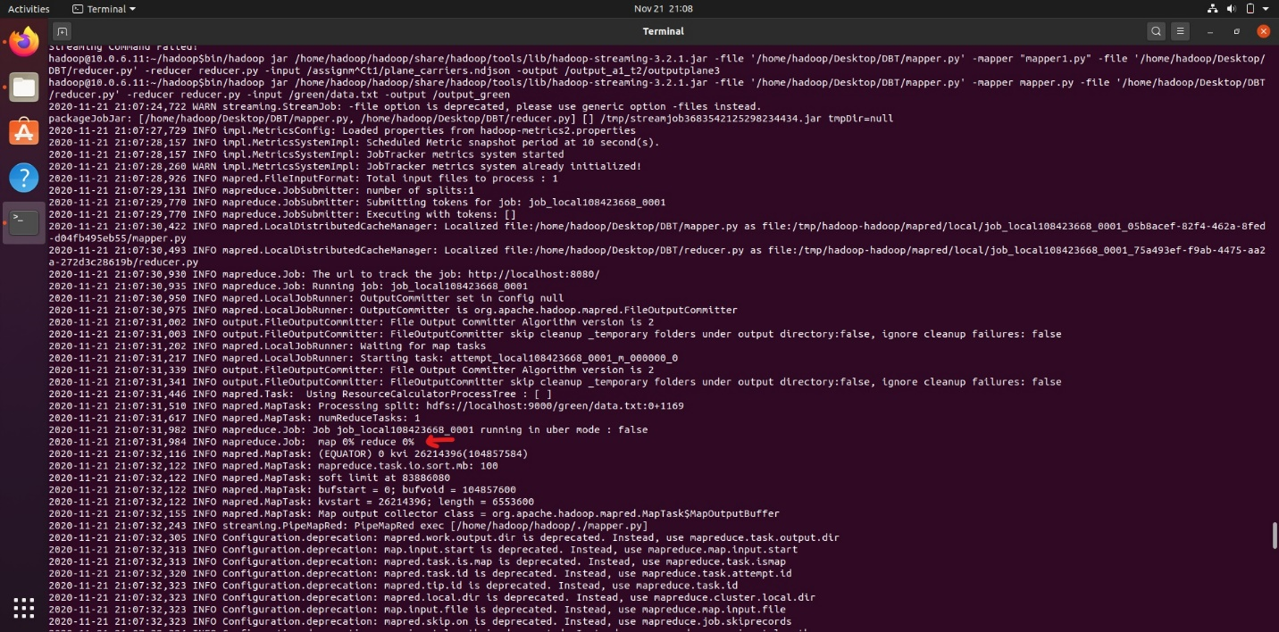

Indicating the completion of map task and reduce task-

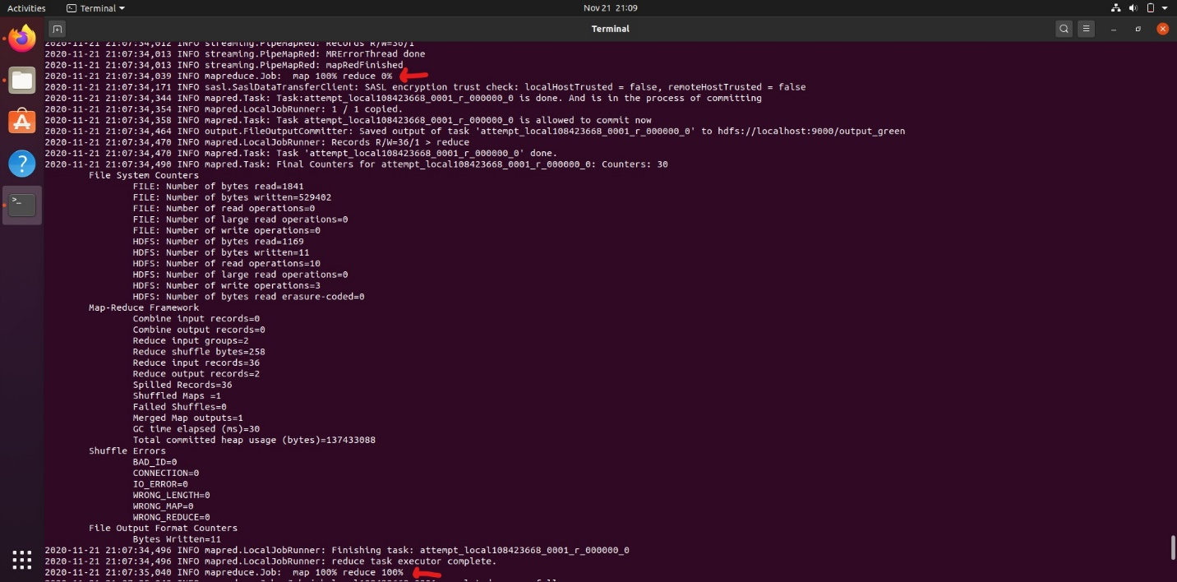

The output and _SUCCESS file are written into the directory called output_green.

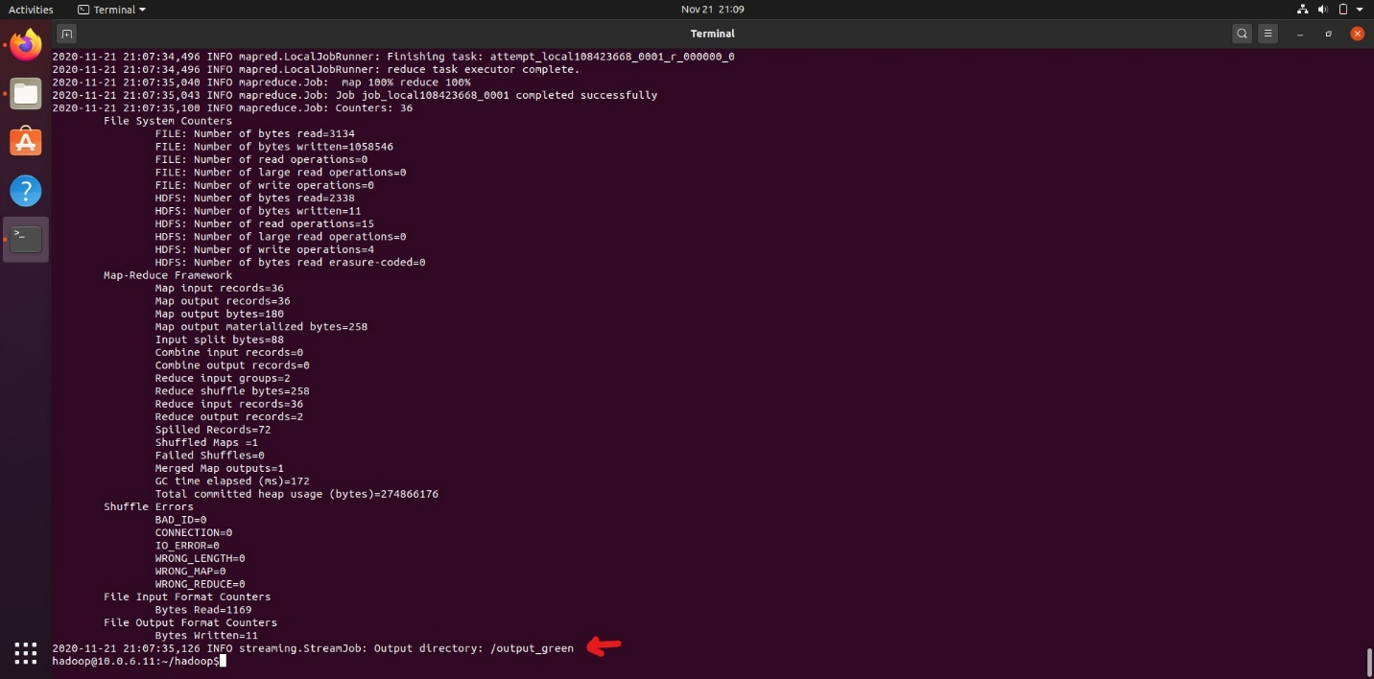

The part file which contains the output has the content as follows-

